BINGEN CITY COUNCIL MINUTES

November 7, 2023

Meeting Via Teleconference and In-Person

The meeting was called to order by Mayor Catherine Kiewit at 7:00 p.m.
Council members present: Phil Jones, Ryan O’Connor, Joe O’Sullivan, Izzy Schroder and Brittany Spratt. Staff present: City Administrator Krista Loney, Fire Chief Carl Spratt. Audience present: Jamin Ankney, Nancy Wetch, Michael Stahl, Holly Rashmi, Ali Rashmi, Chrstine Hansen, Jack Kay, Peter Wright, Brad Schiff, Jeri Fisch.

Public Comment
None.

Meeting Minutes – 10/17/2023
Mayor Kiewit had a correction to the Mayor’s update section: WSDSOT should be WSDOT. Councilor O’Connor made a motion to approve the October 17, 2023 meeting minutes as corrected. Councilor Jones provided the second and the motion carried.

Fire Update
Chief Spratt presented the October 2023 fire report with graphs. There were 41 calls in October bringing the year-to-date calls to 351. The radios purchased under the DNR HB1168 grant have arrived. There is some programming and installation to be done. There was bay damage to one of the fire doors recently. The button on the remote that closes the door after the trucks have cleared was broken and has been replaced. Administrator Loney is working with Overhead Door of Portland to get the door repaired. It is presently working.

Police Update
Chief Hepner was not in attendance.

Oak Street Reservoir Progress Estimate 3
Jamin Ankney from Gray and Osborne attended the meeting to walk Council through this progress estimate. The contractor is nearing completion of the site work and will be working on forms and pouring foundation November 11-15, 2023. The tank is scheduled to arrive on December 4, 2023 and completion of the project is slated for mid-March 2024.

Mayor Kiewit inquired what is being done with the rock that has been excavated from the reservoir site. Ankney stated that he doesn’t know where it is going.

Councilor O’Sullivan asked about the impact of weather conditions on the tank installation. Ankney stated that progress would slow to handle things like snow removal as necessary.

Mayor Kiewit asked if the City could be notified when the tank has been shipped. Ankney stated that he will make sure the City is notified.

Councilor O’Connor made a motion to approve Progress Estimate 3. Councilor Jones provided the second and the motion carried.

Wastewater Treatment Plant Capital Facilities Plan Presentation
Nancy Wetch from Gray and Osborne attended the meeting to present the capital facilities plan that G&O developed in partnership with the team at the Bingen Wastewater Treatment Plant. Wetch reviewed conditions and recommendations regarding the headworks, bioselector, oxidation ditch, secondary clarifiers, return activated sludge pumps, UV disinfection system, effluent pumping station, digester building, water activated sludge pumps, aerobic digesters, dewatering system, plant drain pumping station, electrical systems, and operations building. The summary from the Capital Facilities Plan is included here:

Following is a list of equipment replacements that is recommended at the WWTF. As noted
throughout this chapter most of these replacements are recommended based on the age of the
equipment or the discontinuation of the technology. City Staff was consulted to prioritize these
improvements. Prioritization and cost estimates are presented in Chapter 3.

- Headworks Improvements
- Oxidation Ditch Rotors
- Oxidation Ditch Mixer
- Clarifier Mechanisms
- RAS pumps
- UV Disinfection System
- Effluent Pump Station
- Digester building ventilation system and building repairs.
- WAS pumps
- Aerobic Digesters
- Dewatering System
- Plant Drain Pump Station
- Electrical Power Distribution System
- Electrical Control System
- Operations Building upgrades

Table 3-1 Prioritized Capital Improvement Plan

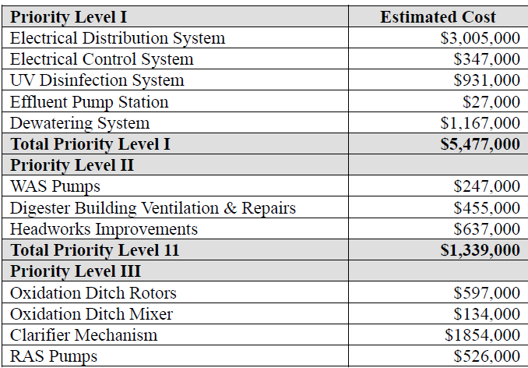
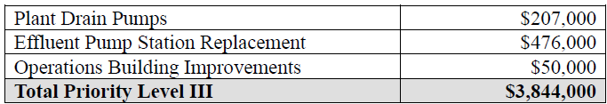

Wetch will submit the Capital Facilities Plan to the Washington State Department of Ecology for their concurrence and the plan will be adopted at a future Council meeting.

Public Hearing – Ordinance 2023-12-745 Adding BMC 5.16 Vacation Rentals
Mayor Kiewit opened the public hearing at 8:02 p.m. and invited those present to share their comments on the proposed Vacation Rental process for Bingen. Holly and Ali Rashmi began their comment asking if the Bingen vacation rental rules are different from the White Salmon rules and was told that they are. Holly shared that she feels the annual fee of $285 is high since they already have to pay for a business license and pay lodging taxes. Administrator Loney explained that all $285 of the annual fee will be used to pay Granicus, the third-party entity that will monitor compliance for the short-term rentals. Loney also explained that the lodging taxes are paid by the person staying at the vacation rental and that those dollars are used by the City of Bingen to provide grants for events and programming that drives tourism to the area, encouraging return guests at vacation rentals. Holly paused and introduced herself and her partner Ali, who has been coming to Bingen to kiteboard since he was 12 years old. Holly and Ali own their home in Bingen, use it frequently, and rent it as a vacation rental when they are not in town. Holly also expressed that she feels that having top-priority on a license for only five years is too short.

Jeri Fisch expressed her gratitude to Council for the careful consideration of this topic. She stated that the fee does feel high. She stated that she is grateful that the inspection that owners must complete is a self-inspection instead of having a third-party in her home. She also stated that the self-inspection will be more of a guideline for homes like her rental which is 900 square feet and would be over-run with fire alarms if they were placed where the inspection sheet suggests. Jeri asked how many vacation rentals a person can have and was told that the draft code limits vacation rentals to one per licensee. Mayor Kiewit pointed out that the licensee definition was taken from the Manzanita code.

Christine Hansen pointed out that the fee feels high.

Discussion ensued regarding the 5-year license limit. That limit began at 3-years. Holly stated that it seems like those who already have vacation rentals should get to continue to have licenses or they might have to sell their vacation homes. Councilor O’Sullivan pointed out the hard issue that has been a part of this discussion from day one: it is not the City’s responsibility to ensure that someone’s investment property nets them a profit. Councilor Schroder inquired about equity. Administrator Loney added onto that point by asking where the equity is for someone to have a license for 10 years, thereby denying a license to someone else who wants to have a vacation rental several years later if the limit has been reached. Councilor O’Connor pointed out that if the limit is reached and there is a backlog of people who want to have a vacation rental and there are no permits left perhaps Council could review the code at that time.

Mayor Kiewit closed the public hearing at 9:10 p.m. and asked council members individually. Councilor O’Sullivan said that he would be comfortable with 10 years and proposed a compromise at 7.5 years. Councilor Spratt said that she would be comfortable with 10 years. Councilor O’Connor stated that he would be comfortable with 10 years. Councilor Jones stated that he would be comfortable with 10 years. Councilor Schroder stated that she will hold firm to a five-year limit followed by a lottery system.

Councilor Jones made a motion to adopt Ordinance 2023-12-745 Adding BMC 5.16 Vacation Rentals with the condition that the license term is 10 years. Councilor O’Sullivan provided the second. The motion carried with the votes as follows:

Jones - yea
O’Connor - yea
O’Sullivan - yea
Schroder - nay
Spratt – yea

Public Hearing – Ordinance 2023-13-746 BMC 10.14 Stopping, Standing and Parking
Mayor Kiewit opened the public hearing at 9:19 p.m. Administrator Loney began by explaining that the modifications to the code were suggested by Mayor Kiewit and Bingen-White Salmon Police Officer Garique Clifford to align Bingen code with state code. The draft code was reviewed.

Councilor Schroder made a motion to continue the public hearing to the November 21, 2023 meeting. Councilor Jones provided the second and the motion carried.

Public Hearing – Preliminary 2024 Budget
Mayor Kiewit opened the public hearing at 9:32 p.m. Administrator Loney provided a memo to Council outlining the sizeable changes to the 2024 budget which include vacation rental revenue and expenses, a $25,121 increase to the police budget for a new hire and taser contract, $18,940 increase to the Fire budget, and $22,328 increase to Risk management insurance. Council reviewed the line-item budget. The public hearing was closed at 9:53 p.m. There is no council action necessary at this time. The ordinance about ad valorem taxes will be heard at the November 17, 2023 council meeting.

Staff Updates
Administrator Loney had the following updates for Council:
- Loney and Mayor Kiewit met with WSDOT about an advanced relocate of the waterline on East Steuben that will be impacted by the roundabout/underpass. WSDOT will connect with Gray and Osborne to discuss working the relocate into the WSDOT project to save costs.
- Loney, Mayor Kiewit, and Superintendent Spratt met regarding the East Steuben waterline and recommend a 3-phase approach for replacing the line. The first phase is approximately 200-400 East Steuben to replace 2” line with 2” line at a cost of approximately $600,000. Loney has a draft Public Works Board emergency grant application ready for Mayor Kiewit’s review. Council will need to approve some documents at the November 21 meeting to allow this application to move forward.
- The TIB-funded street work in Bingen is complete and the paperwork has been finalized with TIB as of 11/2/2023. Bingen can expect reimbursement no later than December 1.
- Loney is working with SDS Lumber on a Shoreline Substantial Development Permit for their new kilns.

Mayor’s Update and Council Comments
Mayor Kiewit announced the Association of Washington Cities award that Bingen won for having excellent claims history with RMSA insurance. The work at Daubenspeck Park continues if Council could please put the word out for volunteers.

Councilor Joe O’Sullivan formally resigned from Bingen City Council with many regrets. He has relocated for work.

Councilor Schroder announced that she will not be in attendance at the November 21 meeting. Councilor O’Connor will attend remotely to ensure that there is a quorum.

Voucher Approval

Payroll Checks (Dated 10/31/2023) and Payroll EFT (Dated 10/31/2023) totaling $47,661.86; General Fund - $15,543.91, Street Fund - $7,772.92, Water Fund - $4,468.11, Sewer Fund - $1,328.76 and Treatment Plant Fund - $18,548.16

Councilor Schroder made a motion to approve the Payroll dated October 31, 2023. Councilor Spratt seconded the motion, and it passed unanimously.

Claims Checks (Dated 11/7/2023) totaling $341,111.99; General Fund - $204,275.54, Street Fund - $2,993.99, Street Construction & Maintenance Fund - $68,367.34, Water Fund - $25,504.01, Sewer Fund - $3,735.31, Treatment Plant Fund - $9,160.71, Water Short-Lived Assets Reserve - $2,148.84, Water Capital Reserve Fund - $24,569.14, and Court Remittance Agency Fund - $357.11.

Councilor Schroder made a motion to approve the Claims dated November 7, 2023. Councilor Spratt
seconded the motion, and it passed unanimously.

Adjournment
Mayor Kiewit adjourned the meeting at 10:12 p.m.

